Introducing Platform Surface Interior Angle and Its Role in Flake Formation, Size and Shape

Four ways archaeologists have tried to gain insights into how flintknapping creates lithic variability are fracture mechanics, controlled experimentation, replication and attribute studies of lithic assemblages. Of these, fracture mechanics has the advantage of being based more closely on first principles derived from physics and material sciences, but its practical application to controlled experimentation, replication and lithic studies more generally has been limited. Controlled experiments have the advantage of being able to explicitly quantify the contribution of individual variables to knapping outcomes, and the results of these experiments have provided models of flake formation that when applied to the archaeological record of flintknapping have provided insights into past behavior. Here we attempt to provide some linkage between fracture mechanics and the results of the controlled experiments to increase its explanatory and predictive power. We do this by looking for the impact of the Herztian cone of percussion, a constant in fracture mechanics, on flake platforms. We find that the platform width is a function of the Hertzian cone constant angle and the geometry of the platform edge. This finding strengthens the foundation of one of the models emerging from the controlled experiments and with some additional work should make it possible to merge more of the experimental results into a more comprehensive model.

# Introduction

There is considerable literature dedicated to better understanding how flakes form. Roughly speaking, this work falls into several broad categories which we can call fracture mechanics (e.g. Cotterell and Kaminga etc., Speth 1972), controlled experiments (e.g. Speth, Pelcin, Dibble etc.), replicative experiments (e.g. Eren etc.), and attribute analysis of archaeological assemblages. These approaches have each their own strengths and weaknesses; however, one way to understand the differences between them is in the directionality of inference. Fracture mechanics starts with first principles, or laws drawn from physics and material sciences in particular, concerning how fractures should form in brittle solids to then make deductive predictions about how flakes should look (size and shape) under varying conditions (where the core is struck, the hammer type, how the platform is prepared, the angle of strike, etc.). To the contrary, controlled and replicative experiments and studies of actual lithic assemblages look at empirical regularities in size and shape under varying conditions to build, inductively, statistical models of flake formation from which one can try to infer first principles. Both approaches are, of course, valid and useful, and the relationship between what is learned from actually doing (experiments) and what is learned from knowing how it should work in principle (fracture mechanics) is circular with each informing the other in an iterative loop.

Understanding first principles causality from statistical modeling, however, is challenging. McElreath (2018) gives the example of trying to understand the physics behind race cars by measuring their attributes. Knowing the speed and handling characteristics of each car, eventually the right things could be measured on each car to build statistical models with enough predictive power to know how a new car might perform in a race, but it would be quite difficult to infer the general physical concepts (and laws) like torque, angular momentum, friction, conservation of energy, etc. from these statistical models. Of course, with prior knowledge of the physics, finding the right attributes to measure on the cars and statistical modeling are more quickly and accurately done. This is important because even when the physical laws are known, modeling them directly can be prohibitively complex or computationally expensive (e.g. air resistance) whereas experiments and statistical models can more efficiently arrive at useable solutions.

The same is true of studies of flake formation and the role of fracture mechanics within it. Fracture mechanics itself is a massive field of study, but the best examples of its application to flake formation are from the papers of Cotterell and Kamminga () and of Speth (1972). These papers start with the physics of fracture mechanics in brittle solids to then explain how flakes are formed and, therefore, why they vary. Some aspects, like the bulb of percussion, are more easily directly accounted for in fracture mechanics whereas for other attributes, like flake size and shape, the conceptual and mathematical frameworks are provided. However, as with the just mentioned example of air resistance, translating the physics of how flakes are formed into a workable model that can predict flake size and shape given the relevant parameters (e.g. core shape, angle of blow, force of blow, etc.) has not come to pass (cf. Speth 1972), and it may not come to pass any time soon. [give example of age of the known universe fracture mechanics model].

So instead, while some papers in controlled experiments in flake formation may cite papers from fracture mechanics, their approaches are all based on statistical modeling. Speth’s work on this topic makes a good example. His 1972 paper uses fracture mechanics to derive a formula to predict flake size which is then tested against a set of actual flakes from a prehistoric site. By 1975 and again in 1981, Speth had moved to experimental approaches (ball bearings on glass) and the connection back to fracture mechanics had all but disappeared. Dibble goes further and simply dismisses fracture mechanics from the start as nearly irrelevant (Dibble and Whittaker 1981). Instead of looking to fracture mechanics for insights into what to study, experimental studies are being informed by replicative knappers and observations on how actual lithic assemblages vary. Dibble is explicit in stating that his experimental research is based on what knappers would have been able to control (Dibble and Whittaker 1981; Dibble 1997). Coming back to the race car analogy, we are carefully building cars controlling for engine size, wheel configurations, foils, etc., things that are generally thought to be important for making a car go fast, and then measuring their speeds. Again, though, because it is also difficult to go in the other direction (from statistical modeling to first principles), the controlled experiment papers have not produced a general model of how flakes form. Instead, we have a series of statistical models that are difficult to relate to one another. The strongest and most influential of these is the model of Exterior Platform Angle and Platform Depth, or the EPA-PD model.

The EPA-PD model states that flake size (mass) is primarily a function of two important variables: exterior platform angle (EPA) and platform depth (PD). Increasing either increases flake size, but the relationship between the two is geometric such that at higher values of EPA changes in PD have a greater effect on flake size. The EPA-PD model has been replicated in multiple experiments, including those in the material sciences (Dibble and Whittaker 1981; Dibble and Pelcin 1995; Speth 1975, 1981; Dibble and Rezek 2009; Lin et al. 2013; Chai and Lawn 2007a), is known to work across raw material types (Dogandzic et al. 2010), is known to work in actual lithic assemblages (Dibble 1997; Lin et al. 2013; Rezek et al. 2018), and is argued to have a stronger effect on flake size and shape than does core surface morphology (Pelcin 1997; Rezek et al. 2011). The EPA-PD model of flake formation, however, has some weaknesses. For instance, beveled flakes, where the area behind the platform is thinned, are not easily included into the model (Leader et al. 2017). Beveled flakes are typically larger (mass) than the EPA-PD models predicts given their lower platform depths. The EPA-PD model also does not explain why flake size and shape change with varying angles of blow and platform shape (Clarkson and Hiscock 2011; Dibble and Rezek 2009; Magnani et al. 2014), and it does not account for flake width, which is obviously a major component of shape. It is also worth noting that while the percentage of variability in mass explained by the EPA-PD model, or R2, is typically high in the Dibble glass experiments, it is far lower in actual lithic assemblages (Clarkson and Hiscock 2011). It is low enough that its utility for measuring retouch intensity (i.e. knowing how much mass has been removed from a flake through retouch) is limited (Hiscock and Tabrett 2010; Dogandzic et al. 2010), and so there have been various proposals to improve the statistical modeling of flake mass from different sets of measures (Braun et al.; Dogandzig et al.; Archer et al.). Again, though, without a general theory, it is not really clear why one measurement technique should work better than another, and success is measured by R2 values again empirical data instead of theoretical predictions (e.g. Muller and Clarkson; Archer). The problem is that we still do not know really how flake formation works in a way that translates to measurable attributes.

Here we propose to build on the EPA-PD model by 1) switching the focus from variables controlled by the knapper to variables that might be more directly related to flake initiation and formation, and by 2) drawing insights from the fracture mechanics literature in doing so. In particular, we start with the proposal that Hertzian cones, a constant in percussive fracture mechanics, have a measurable impact on where the fracture initiates, and this in turn plays an important role in determining flake size and shape. We model this proposal as follows. When a core is struck, the fracture initially travels from the point of percussion at a fixed angle that corresponds to the Hertzian cone angle. This angle has been measured in glass at 68.5 degrees or 137 across the full cone (Roesler 1956) and is similarly reported to be 136 degrees in Cotterell and Kaminga (1987). Importantly, this angle varies only with raw material type (). Changing the type of indenter (hard versus soft hammer), the size of the indenter, or the force with which the material is struck do not change the cone angle (). Changing the angle of blow likely changes the orientation of the cone, but it does not change its angle (). When the fracture, spreading at this constant angle, encounters the core surface, a fracture plane forms roughly parallel to the core surface (in other words at an angle roughly equivalent to the EPA). At this point the importance of the Hertzian cone angle quickly diminishes, and our model no longer applies. While we are unsure where exactly the Hertzian cone will first intersect the core surface, we take as our proxy of this model the location where it initiates on the platform edge (where the platform meets the core surface), and we measure the angle between the point of percussion and these two points. This angle we term the ‘platform surface interior angle’ or PSIA, and our prediction is that this angle is a constant that directly follows from the Hertzian cone constant. If this model is correct, then it means that platform width is determined by the geometry of the platform edge in relation to where the core is struck. In this way, platform width is integrated into the EPA-PD model, and how PD actually impacts flake size becomes based in fracture mechanics. Additionally, this model is not without behavioral implications in that it could explain how the manipulation of the platform impacts the size and shape of flakes.

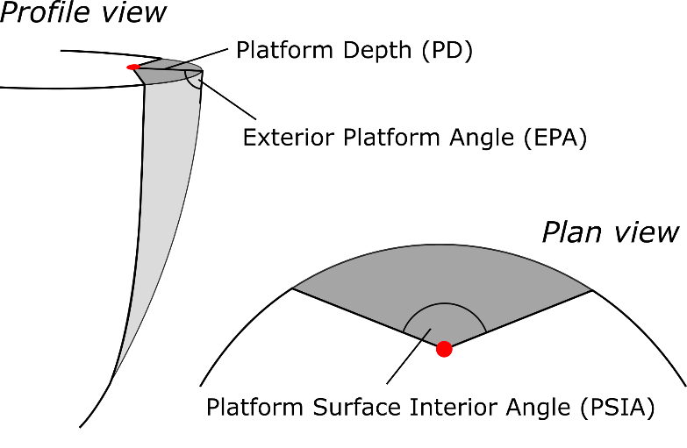

To test this model, we examine several sets of flakes, including flakes produced in the Dibble glass experiments and flakes from replication experiments, using several methods to measure the PSIA. We find that mean angle in all datasets, regardless of how it is measured, is the same (approximately 136 degrees) and quite consistent with above mentioned values for Hertzian cone formation (Cotterell and Kaminga 1987). There is some variability in the PSIA, and it is clear that this variability cannot be solely attributed to measurement error. In the Dibble glass experiments, where key variables are controlled, there is some indication that the PSIA responds to the angle of blow. Our finding is consistent with all of the empirical results of the Dibble experiments and it explains some of the patterns in those data that previously were unaccounted for. When PSIA is combined with exterior platform angle, we may have a model for flake formation that can explain a larger portion of the variability we see in stone tool assemblage and that may allow for a closer link to predictions coming from fracture mechanics.

# Materials and Methods

We examine the platform surface interior angle in three different datasets. First, we examine glass flakes and cores coming from the Dibble controlled experiments in flake formation (Dibble and Rezek 2009; Rezek 2011; Lin et al. 2013; Magnani et al. 2014; Leader 2017). This dataset has the advantage that a number of potentially important variables are either controlled for or measureable. These include the exterior platform angle, the angle of blow, the hammer type, material knapped, and metrics such as platform thickness, platform width, flake length, width and thickness, and flake weight. Hereafter this dataset if referred to as the Dibble glass data. Second, we attempt to validate the findings from the Dibble glass data by measuring the platform surface interior angle in a large set of flakes coming from replicative experiments. These flakes were made by so and so and so and so with the intent of replicating various core reduction strategies from the initial formation of the core through to flake production and core maintenance. For each of the flakes coming from these reduction series, the technology and the type of hammer (hard hammer, soft hammer and indirect percussion) are known. Hereafter this dataset is referred to as the Campagne data (see Archer et al. 2020 for additional details on the structure of this dataset). Third, in addition, we measured a small set of flakes produced at the Max Planck Institute in Leipzig, Germany, in the context of teaching, replication, and experimentation. In this case, no details are known about how the flakes were produced, and this set of flakes is used here only to test a method for measuring the platform surface interior angle. One of us (SPM) selected flakes from boxes of debris. Every effort was made to avoid bias, and all flakes with complete platforms and measurable platform widths were retained. Hereafter this dataset is referred to as the MPI data.

The methods used to measure the PSIA varied substantially between the three datasets. First, for the Dibble glass data, we used the following procedure. Dibble and colleagues used several core forms, but the first and most common type is what was called the semispherical core. This core (reproduced here) looks like a loaf of bread with flat, squared off sides and back, and a curved or domed flaking surface. An unworked example of this core type was scanned using an XX surface scanner. The resulting mesh was then processed in R to rotate the platform to be perpendicular to the Z axis (or coincident with the XY plane). The XY coordinates of the triangles forming the platform were then extracted from this model and a convex hull fit to this cloud of points to have the full outline of the platform on the Dibble semispherical cores (Figure 1). Next, we extracted just the portion of the outline that is where flakes are struck from these cores, and we fit a polynomial curve to these points. Using the formula for this curve, we created a series of equally spaced (in X) points along the platform edge (see (see Figure 1). We then filtered Dibble’s glass data to have only flakes made from the semispherical cores by hard hammer. We include only flakes with a feather termination, and we exclude flakes coming from experiments on platform beveling (Leader et al. 2017) and so-called ‘on-edge’ core strikes (Magnani et al. 2014). Knowing that Dibble and colleagues tried to strike flakes from these cores at the center or peak of the core surface curvature, we use the platform depth reported for these flake to position the point of percussion relative to the set of platform edge outline points described above. Next, working back from the platform edge, the locations left and right of the point of percussion and on the platform edge points that yields a platform width equal to the reported platform width for that flake is determined. Finally, the PSIA is calculated (arc-cosine of the dot product of two normalize vectors) as the angle between the two line segments formed by the left platform width point and the point of percussion and the right platform point and the point of percussion.

[I will insert a new figure showing a Dibble glass core and how the measures we talk about here are made]

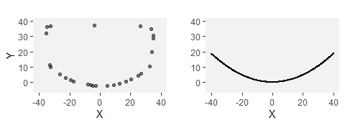

Outline of Dible core surface (left) and the polynominal fitted to the core edge (right).

We note that there are several potential sources of error in this method. First, we are assuming that each flake is struck from the center of the core, and while this was the intention in the Dibble experiments, there is certainly some error associated with this. Second, we are assuming that the flake removal is centered on the center of the core and parallel to the core surface (i.e. that it is not twisted to one side or the other). To the extent that either of these assumptions is invalid, it will impact the angle calculation. [could simulate this to get an idea of the error]

To verify the angles computed in this way from the Dibble glass data, we also measure this angle directly on a subset of these flakes. We use two techniques for this measurement to begin to test how to measure the PSIA as part of more traditional lithic attribute measures. In the first method, we measure the three sides of the triangle formed by the two platform width points and the point of percussion using digital calipers precise to .01 mm [check this]. Using standard trigonometric formulas, we then calculate the interior angle of this triangle that corresponds to the platform surface interior angle as described above. In the second method, we use a digital goniometer precise to XX degrees [check this] to record this angle. The joint of the goniometer is positioned at the point of percussion and the jaws positioned to cross the two platform width points. Both of these methods come with possibilities for error. Both are impacted by one’s ability to pinpoint the point of percussion. In the Dibble glass flakes, because the core edge is standardized, identifying the the two platform width points is fairly straightforward. However, in the goniometer method, taking the measurement to these points while avoiding the curvature of the bulb of percussion is not without some difficulties.

Second, for the Campagne data, we use the following procedure. All of the flakes were scanned using an Artec surface scanner. Each of the flake meshes was then landmarked (see Archer et al. 2020 for additional details on the scanning and landmarking). For our purposes, three of these landmarks are important: the two points (left and right) where the interior platform intersects the core surface (i.e., the two ends of the platform width) and the point of percussion. These three points are homologous with the three points described above for computing the platform surface interior angle. This angle, therefore, can be once again computed as the dot product of these two line segments. However, there is an important difference in that with the Dibble glass data all computations are with two dimensional line segments and in the Campagne dataset the line segments are in three dimensions. In the latter case, the angle is computed in a two dimensional plane that is coincident with both line segments, but we note this difference because it could introduce a certain amount of incomparability in the two datasets. Our expectation is that these angles could average larger than the Dibble glass data because, for instance, lifting the point of percussion relative to the two platform points would result in a larger PSIA.

Third, for the MPI data, we use only the goniometer method described above. One of us (MW) made the measurements with instructions only on the mechanics of the measurement. To avoid bias, MW was given no prior knowledge of the results of the previous studies outlined above or of how PSIA may function in flake production. In the course of measuring the flakes, several problematic platforms were identified where the measurement of the PSIA was not as clear as the person selecting the flakes (SPM) had initially believed. These flakes were removed from the analysis.

We use the R () statistical environment to do this analysis. This paper is an rMarkdown document, and it is included in the supplementary information along with the data files needed to compile the document and replicate all of the figures, tables, and statistics.

# Results

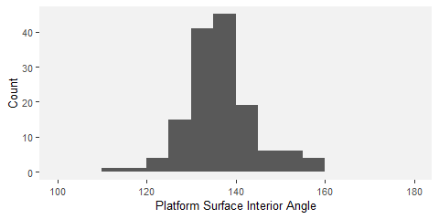

Distribution of estimated platform surface interior angles (PSIA) based on the Dibble glass flakes.

Figure 2 shows the distribution of platform surface interior angles in the Dibble glass dataset. The distribution has a mean of 136.49±7.56. Variation in this angle does not seem to be related to platform depth, exterior platform angle or mass (Figure 3). There is a relationship between platform width and the platform surface interior angle such that larger angles result in wider platforms (see Figure 3).

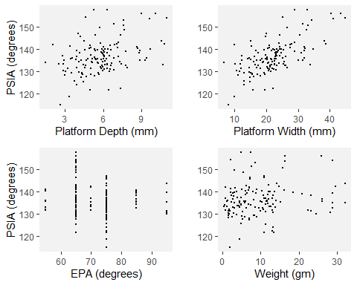

PW, PD, EPA and mass against the estimated platform surface interior angles based on the Dibble glass flakes.

There also appears to be a relationship between the angle of blow and the PSIA (Figure 4). While there are fewer cases with angles of blow less than 20, there is some indication in the data that lower angles of blow are correlated with lower PSIA. However, once the angle of blow is between 10-20 degrees or higher, the angle of blow is not correlated with the PSIA.

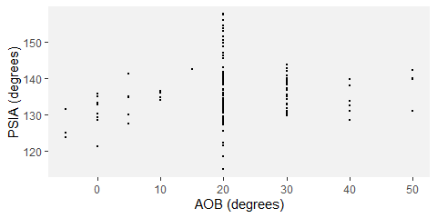

AOB against the estimated platform surface interior angles based on the Dibble glass flakes.

Another way of looking at the relationship between platform width and PSIA is to calculate what the platform width would be if the PSIA is a constant and compare this to the actual platform width. We can do this by placing the point of percussion on the same platform outlines as above using the known platform depth for each of the flakes in the Dibble glass data set. We then use the average PSIA computed above to extend two vectors from this point of percussion to the platform edge. Where these vectors intersect the platform edge defines the left and right limits of the platform width. This estimated value is then plotted against the actual, measured platform widths (Figure 5).

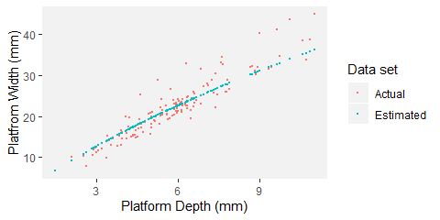

The actual platform depth to platform width data from the Dibble glass core flakes and the estimated platform width using the average platform surface interior angle calculated previously.

Figures 6 and 7 show comparisons of the results of the estimated PSIA presented above with direct measurements of this angle on a sample of 49 of the Dibble glass flakes. For this sample, the PSIA is 135.71±4.86. When measured with a digital goniometer the angle is 133.44±4.61; when measured with digital calipers and calculated using trigonometry, the angle is 135.86±8.85.

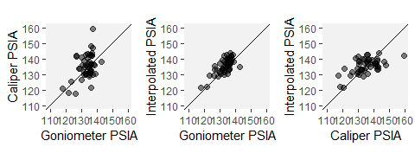

A comparison of the interpolated platform surface interior angle, this same angle as calculated from caliper measurements, and this same angle measured with a goniometer. All measures are in degrees.

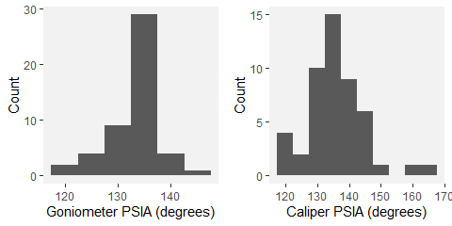

The distributions of platform surface interior angle as directly measured with a goniometer and as calculated from caliper measurements.

The distribution of the PSIA for the 568 flakes in the Campagne dataset is shown in Figure 8 with color coding for the type of percussion technique. Here the mean platform surface interior angle for all flakes is 138.63±13.27. Punch flakes have a lower platform surface interior angle (stats), and soft hammer flakes have a mean of XX. When we look at only the hard hammer flakes, which is the technique used in the Dibble glass dataset, the mean platform surface interior angle is 140.36±12.38.

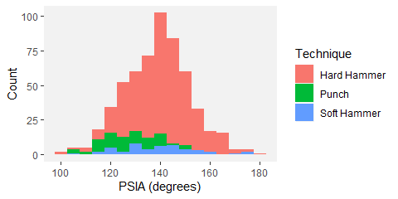

Distribution of platform surface interior anglesin the Campaigne data set color coded by percussion type.

In the Campagne data, PSIA does not covary with platform width, platform thickness or the shape of the platform (as measured by the ratio of platform width to platform depth). Though sample size is perhaps a problem, there is perhaps an indication that for larger platform depths, there is less variability in the platform surface interior angle.

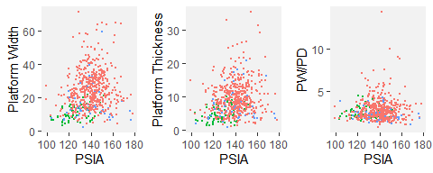

Platform surface interior angle as a function of platform width, platform depth, and EPA in the experimental flake collection. Color coding is the same as in Figure 8.

The distribution of PSIA in the MPI dataset as measured by a digital goniometer is presented in Figure 10. This dataset contains 67 flakes, and the mean is 137.75±10.97, in keeping with the other datasets.

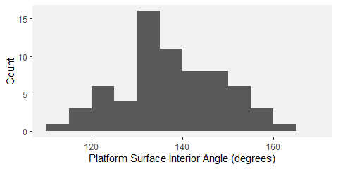

Distribution of platform surface interior angle in the MPI flakes dataset as measured by a digital goniometer.

# Discussion

Each of the datasets and measurement systems used to determine the PSIA yielded very similar results, and these results are consistent with the prediction based on the already known and constant angle of Hertzian cones (136-137 degrees). While these results directly incorporate the formation of platform width into the EPA-PD model of flake formation, they also suggest that the existing model requires additional nuance. All other things being equal, the relationship between PSIA and platform width indicates that what determines the size of the platform, and hence the flake, is how far into the core it is struck. Specifically, because of the constant PSIA, the deeper into the core the flake is struck, the greater the platform(?) width and depth will become. However, and this is the nuance, while platform thickness is normally a good proxy for how far into the core the flake is struck, it is not the same thing. Beveled flakes illustrate why this is true.

Beveled flakes are ones where material is removed behind the platform prior to striking the core. Dibble and colleagues recognized that beveling altered the EPA-PD model of flake formation such that the interaction of platform depth and exterior platform angle no longer predicted flake size (Leader et al.). Namely, beveled flakes have too thin a platform for their size. However, if we expand the EPA-PD model by considering the additional effect of PSIA on platform width, the bevel flakes no longer represent anomalies. To illustrate this point, we examine some of the beveled flakes in the Dibble glass dataset.

In the Dibble glass dataset there are 11 beveled flakes coming from semispherical cores and otherwise conforming to our selection criteria. They are plotted in Figure 11 along with the non-beveled flakes. It is clear that the presence of platform beveling changes the relationship between platform depth and platform width – for a given platform width, the beveled flakes have much shallower platforms (smaller PD) than expected. In the original form of the EPA-PD model, this difference is hard to reconcile (Leader et al. 2017). Here, to illustrate the power of PSIA to explain these flakes, we build a linear model to predict platform thickness from PSIA and platform width on the non-beveled flakes in the Dibble glass dataset. We then use this model to predict the ‘theoretical’ platform depth of the beveled flakes. Because the PSIA is not known for these flakes, we substitute the average PSIA as reported above in its place. When this is done, the ‘theoretical’ platform depth for the beveled flakes plot on the same trend line as the non-beveled flakes (see Figure 11).

This reconstructed platform depth can then be used to improve the EPA-PD model to give better estimates of flake size. The main aspect of size that Dibble abd colleagues have focused on for the beveled flakes is weight (Leader et al. 2017), and so we model flake weight as a function of EPA, platform depth and the interaction of the two (see Figure 11). The cube root of weight is used to correct for the different dimensions in the model. Next, we use this same model to predict flake weight in the beveled flakes using the platform depth as originally measured on these beveled flakes. In this case, the predicted flake weights are much too low (see Figure 11). Finally, we use the modeled platform depth, as calculated above, to predict flake weight again using the non-beveled flake model. In this case, the flake weights plot in among the rest of the non-beveled flakes (see Figure 11). Thus the beveled flakes are the correct size when we think of PD in the EPA-PD model not as a measure of platform depth but rather as a measure of how far into the core the flake is struck, which then determines the flake width via the PSIA and the platform shape. Beveling does not change the expected size of these flakes when flake formation is viewed this way. Rather, beveling is but a form of platform morphology, whose variability alters the relationship between platform depth and platform width (Figure xx).

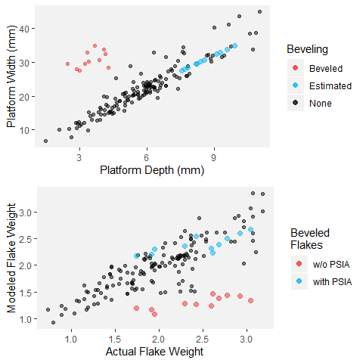

Platform depth to platform width including beveled flakes (left). Estimated points are the beveled flakes with recalculated platform depths based on the average PSIA and their actual platform width. To the right, the actual flake weight is compared to the predicted flake weight based on an EPA-PD model for non-beveled flakes. The predicted weight using the actual (w/o PSIA) and the modeled (with PSIA) platform depths for the beveled flakes are then plotted as well.

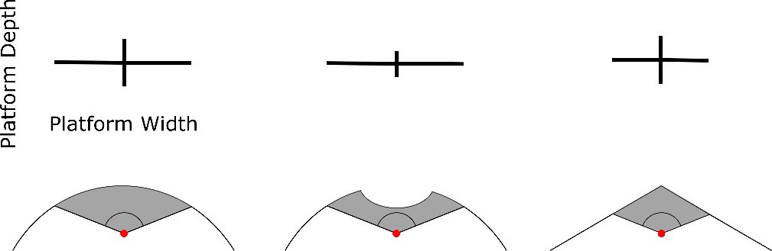

There is some indication in the Dibble glass data that the angle of blow may impact the PSIA. At low angles of blow (perpendicular to the core surface), the PSIA is below average, and it appears to increase until the angle of blow reaches between 10 and 20 degrees (from perpendicular), after which the PSIA remains essentially unchanged (refer to previous figure). With the caveat that the Dibble glass data set has very few cases with angles of less than 20 degrees, the fracture mechanics literature suggests a relationship like this. The angle of blow changes the direction, though not the size, of the Hertzian cone such that flakes struck from cores with a high angle of blow (oblique strike) should have “steeper and less prominent cones and less salient bulbs of percussion than flakes which are struck more steeply [or more perpendicular]” (Speth 1972:38). Experimentally, however, Magnani et al. (2014) seem to find the opposite. They report that a negative angle of blow (here values less than 0 meaning a strike directed into the core rather than towards the core surface) have smaller bulbs relative to the weight of the flake. In our Campagne data set, we see a difference between flakes made from direct hard-hammer percussion and those made with a punch technique. The latter cluster at the low range of PSIA. This difference could be interpreted as reflecting a difference in the angle of blow in that punch flakes are more likely to be struck perpendicularly to the platform surface. More work needs to be done, in particular analyzing Dibble glass data set where angle of blow is well controlled, but we suggest that increasing the angle of blow has the effect of tipping the direction of the Hertzian cone such that it intersects the core surface not as a circle but rather as an ellipse. Thus while the angle of the cone itself remains unchanged, its intersection with the surface broadens and results in higher platform surface interior angles. Thus, if this model is correct, striking a core with a high angle of blow will result in a larger platform width for a given platform thickness.

The direct measurement of PSIA in a subsample of the Dibble glass flakes shows that our method for finding this angle using the core morphology and platform depth is working. However, there is variability in this angle depending on how it is measured. In general it seems that the direct measurement with a goniometer performs better than the indirect calculation of the angle from three caliper measurements. Of the two systems, the caliper measurements show greater variability than do the goniometer measurements. The caliper method can also fail completely when measurement error produces a triangle with impossible side lengths (e.g. the sum of the two shorter sides does not equal the length of the longest side). Importantly too, this is only knowable once the measures are taken and an angle is calculated, making it much more difficult to correct, whereas the goniometer method produces an angle each time. Our study, however, does not indicate which of the three methods in this case is correct, nor do we know the error associated with any of these methods. Now that PSIA seems to produce results relevant to understanding flake formation, additional studies are required to better know the error distribution on an individual measure. We note too that this error distribution will likely vary with the angle itself, the size of the point of percussion, and other factors that remain to be identified. The question, however, is whether this measurement error will overwhelm patterns, for instance, showing a potential correlation in angle of blow and platform surface interior angle. It is our expectation that with a digital goniometer, direct measurement of the platform surface interior angle can become a standard measurement within an attribute analysis, but this remains to be determined.

We note that our finding that the platform surface interior angle varies around a constant derived from fracture mechanics appears to be consistent with all of the findings to date of the Dibble glass experiments (). Additionally, it perhaps helps explain or account for one of the more counter intuitive findings of the glass experiments, namely that flake size (mass) is not impacted by the force with which the core is struck (Dibble and Rezek 2009). In the EPA-PD model, the amount of force required to remove a flake given a particular combination of EPA-PD is a constant. Similar findings regarding the relationship between load and platform depth was reported in the material sciences (Chai and Lawn 2007b). Subtracting force means that the flake is not initiated. Adding force does not change the shape (size and mass) of the resulting flake. This makes sense in the PSIA addition to the model. In fracture mechanics, it is known that striking a material harder does not change the angle of the Hertzian cone. It will change the size of the cone but not the angle (xx). Thus when a core is struck, how far into the core the Hertzian cone can travel will be a function of force, but where it is destined to intersect the core surface does not change. So striking a Dibble glass core harder at a particular point does not change the platform width, and as a result, the subsequent fracture plane that removes the flake has much less freedom to change the size of the flake.

# Conclusions

Fracture mechanics is a massive field of study with both great potential and great difficulties for understanding flake formation. The potential is that the physical laws and models coming from fracture mechanics are, ultimately, how the actions of knappers are translated to usable flakes. The difficulties are both inherent to the field itself and the complexity of the problem (some solutions require more time and computing power than exists) and relate to the challenges of interdisciplinary work where the equations and goals of one field are terribly difficult to bring into another. This later point is clearly seen in the early fracture mechanics literature and the minimal impact it has had on experimental and replicative studies of flake formation.

This said, our goal here was to return to this literature and to try to find some useful insights that could be translated to a better understanding of the underlying mechanisms (or first principles) of flake formation and that might thereby lead to a better integration of the various statistical models currently in use. To do this, we discarded the existing focus in the experimental literature on what knappers do and instead focused on attributes that may be more directly related to fracture mechanics. Thus we focused our attention on the Hertzian percussion cone as a constant and wondered if it could help explain platform width, an aspect of flake size and shape that up to now has been absent from the dominant EPA-PD model of flake formation. We measured three different collections in multiple different ways and found that in each case the angle formed by the platform width and the point of percussion to be, on average, essentially the same as what is predicted from fracture mechanics for the angle of the Hertzian cone.

We conclude that the platform surface interior angle, or PSIA, is an important determinant in flake size and shape. While it would seem that it is a constant and not under direct control by the knapper, the knapper is exploiting the properties of this angle when preparing the platform and its contact with the platform surface and when deciding how far into the core to strike. In our model, this is how the PD side of the EPA-PD model of flake formation is translated into a flake of a particular size and shape. In other words, it is not the PD that directly structures flake size but rather PD is proxy for how far into the core a flake is struck which then, through the PSIA, structures the size and shape of the flake.

This, however, requires further testing, particularly with beveled flakes where PD performs poorly as a proxy for how far into the core a flake is struck. If the platform surface interior angle performs better in these circumstances, then we will have improved the EPA-PD model and helped to integrate what are now disparate studies (Dibble and Rezek 2009 and Leader et al.). Additionally, while our study shows that the average platform surface interior angle conforms well to predictions from fracture mechanics, it is still clear that there is variability around this mean. Given that there is certainly some chaos in flake formation, we are not sure how much variability to expect. [something about the glass cores versus the flint flakes] However, it is also clear that the model does not work at all for some flakes. We would like to propose that these flakes are not formed by percussion flaking (need to revisit the Cotterell papers and bending flakes, versus percussive flake vs. one other category) and that alternative models will be required in these cases. Clearly more data are required to begin to understand which kinds of flakes fail the platform surface interior angle model, but these flakes should in turn allow us additional insights into flake formation.

# Acknowledgements

The knappers in Campagne. We thank the Max Planck Society for funding portions of this work. SPM, MW, WA, ZR and TD thank Jean-Jacques Hublin for his support this research agenda. Sadly Harold Dibble died before the main findings of this paper were discovered. However, without his vision and his efforts to build a data set of flakes made under controlled conditions, this paper would not have been possible. We dedicate this paper to him.

# References